|  |  |  |  |
| --- | --- | --- | --- |
| **F:\Learning bugs\Foundation Subjects\Dolly the Fly - Science.jpgLyng Primary School Knowledge Organiser** | | | |
| **Topic: Making connections** | **Science**  **Does hand span affect grip strength?** | Year 3 | Summer 2 |



**Notable scientists**

**Marie Curie**

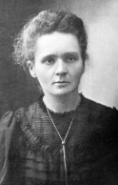

**What should I already know?**

* We have joints and muscles in our body that help us move.
* The nutrient groups and how to have a balanced diet.
* Work scientifically to record and gather data.
* I know that there are forces such as friction that effect moving objects.
* Use scientific methods and to record and analyse my findings.

|  |  |
| --- | --- |
| **What Step On and Goldilocks words will I use?** | |
| **Spelling** | **Definition** |
| friction | A resistance caused when surfaces or objects rub together |
| carbohydrate | An important nutrient for the human body |
| joint | A structure in the body where two parts of the skeleton join together |
| Muscle | Soft tissue found throughout the human body |
| variable | A factor that can be changed in an experiment |
| nutrients | Substances that a plant needs to survive |
| predict | A scientific guess |
| evaluate | To judge the quality of an experiment |

|  |
| --- |
| Investigate! |
| * Set up an enquiry to test how hand span affects grip strength. Plan an investigation by considering variables that will change and stay the same. * Gather, record and interpret data by carrying out the hand span experiment using different fruits! |

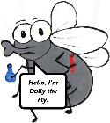

**What will I know by the end of the unit?**

**Forces and magnets**

**Movement and nutrition**

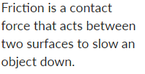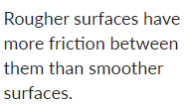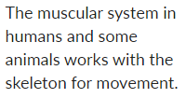

**Rocks and soils**

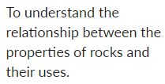

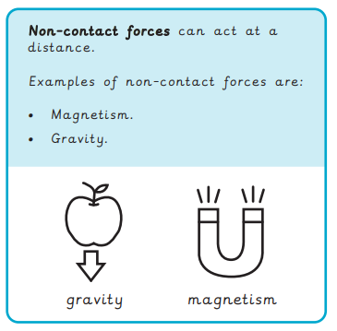

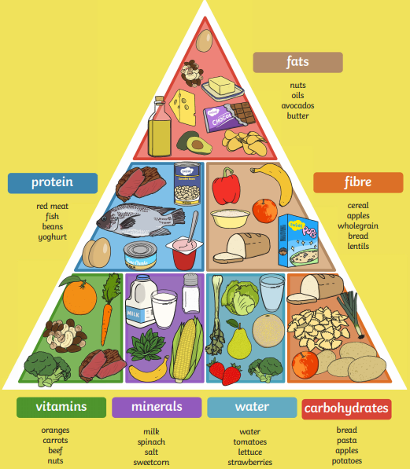

|  |
| --- |
| Our Enquiry Questions |
| * How can I plan a pattern seeking enquiry? * How can I investigate grip strength? * How does friction help with grip? * Why do gloves effect hand grip? * How can I report my findings? |

**Light and shadows**

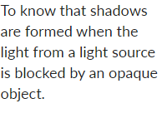

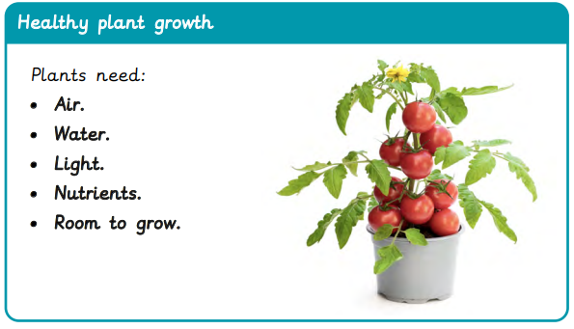

|  |  |  |  |
| --- | --- | --- | --- |
| **F:\Learning bugs\Foundation Subjects\Dolly the Fly - Science.jpgLyng Primary School Knowledge Organiser** | | | |
| ***Topic: Making connections*** | ***Science***  ***Does hand span affect grip strength?*** | *Year 3* | *Summer 2* |

|  |  |  |  |
| --- | --- | --- | --- |
| The muscular system helps humans to… | **S** | | **E** |
| a) move |  |  | |
| b) drive |  |  | |
| c) learn |  |  | |

|  |  |  |
| --- | --- | --- |
| How are shadows formed? | **S** | **C** |
| a) When a light source is blocked by a transparent object. |  |  |
| b) When a light source is blocked by an opaque object |  |  |
| c) When there is darkness |  |  |

|  |  |  |
| --- | --- | --- |
| How many food groups are there? | **S** | **E** |
| 1. 5 |  |  |
| 1. 12 |  |  |
| 1. 7 |  |  |

|  |  |  |
| --- | --- | --- |
| What is germination? | **S** | **E** |
| 1. A plant growing from a seed. |  |  |
| 1. Leaves falling off in autumn. |  |  |
| 1. Water transport. |  |  |

|  |  |  |
| --- | --- | --- |
| What is friction? | **S** | **E** |
| 1. A contact force that acts between two surfaces to slow an object down |  |  |
| 1. A non-contact force |  |  |
| 1. A light source |  |  |

|  |  |  |
| --- | --- | --- |
| A control variable in an experiment is… | **S** | **E** |
| 1. Something that stays the same |  |  |
| 1. Something that changes |  |  |
| 1. Something we can’t control |  |  |

|  |  |  |
| --- | --- | --- |
| Rougher surfaces have… | **S** | **E** |
| 1. Less friction |  |  |
| 1. No friction |  |  |
| 1. More friction |  |  |

|  |  |  |
| --- | --- | --- |
| A non-contact can act… | **S** | **E** |
| 1. At a distance |  |  |
| 1. When two objects are touching |  |  |
| 1. When there’s friction |  |  |

Start of quiz _________________

End of quiz ________________